Department of Computer Science and Engineering
(Artificial Intelligence & Machine Learning)

LAB PROJECT REPORT
on
“ Smart grocery Waste Minimizer’’

Submitted by

A.DEEKSHITH 23911A6672
D.HARSHAVARDHAN 24915A6608

Subject : Machine Learning Lab
Faculty : Dr. N Anusha

2025 -26

Index
1.Abstract: 3
2.Introduction: 4
3.Literature Review: 5
4.Methodology: 6
4.1 System Architecture 6
4.2 Data Collection 6
4.3 Predictive Modeling 6
Models Considered 6
EvaluationMetrics: 7
4.4 Recipe Recommendation Engine 7
4.5 Smart Shopping List Generator 7
4.6 Architecture Diagram : 8
5.Implementation: 9
6.Conclusion 10
7.References: 11

1.Abstract:
Food waste poses a critical environmental and economic challenge worldwide, with households accounting for a major portion due to inefficient consumption and purchase habits.
The Smart Grocery Waste Minimizer proposes a data-driven solution that predicts which food items are likely to remain unused or expire soon, suggests recipes to utilize them efficiently, and generates optimized shopping lists to prevent over-purchasing.
Using machine learning models, the system analyzes grocery purchase history, item shelf life, and consumption frequency to forecast potential waste. It integrates a recipe recommendation engine and a smart list generator for actionable insights.
Success is measured through key metrics such as the percentage reduction in wasted items, average monthly savings, recipe engagement rate, and model precision/recall for waste prediction.
The proposed system bridges sustainability with artificial intelligence, empowering households to save money and minimize environmental impact through smarter grocery management.

2.Introduction:
Food waste remains one of the most pressing issues of the 21st century. According to the United Nations Environment Programme (UNEP), nearly 931 million tons of food are wasted globally each year, with over 60% originating from households. The consequences of this waste extend beyond economic loss — contributing to greenhouse gas emissions, resource depletion, and food insecurity.
Household waste typically arises from over-purchasing, poor inventory tracking, improper storage, and limited meal planning. Current solutions — such as manual grocery tracking apps — fail to leverage the power of predictive analytics and automation.
This project introduces the Smart Grocery Waste Minimizer, a system designed to:
- Predict food items likely to go unused or expire soon.
- Suggest recipes utilizing near-expiry items.
- Generate smarter shopping lists that adapt to user habits.
By integrating machine learning models, recipe APIs, and data-driven shopping recommendations, this system helps users make informed decisions while minimizing household waste.

3.Literature Review:
Numerous studies have explored the intersection of technology and food waste reduction:
- Predictive Waste Management Systems: Previous research [1] used regression models to estimate household waste but lacked personalization in user behavior analysis.
- Recipe Recommendation Systems: Studies [2] integrated ingredient-based suggestions to reduce spoilage but did not include waste forecasting.
- Smart Inventory Systems: IoT-based solutions [3] used sensors to monitor food storage but required expensive hardware and lacked scalability.
The proposed system differentiates itself by combining machine learning-based waste prediction, personalized recipe generation, and shopping list optimization — forming a holistic digital solution for everyday users.

4.Methodology:

4.1 System Architecture
The system consists of three integrated modules:
- Data Collection and Preprocessing
- Waste Prediction Model
- Recommendation Engine (Recipes & Shopping Lists)

4.2 Data Collection
The model uses a user grocery dataset containing:
- Item name and category (e.g., fruit, dairy, grain)
- Quantity purchased
- Purchase and consumption dates
- Shelf life (in days)
- Waste status (used / unused / expired)

4.3 Predictive Modeling
The Waste Prediction Model uses features such as:
- category
- quantity
- shelf_life
- avg_consumption_rate
- time_since_purchase

Models Considered
- Logistic Regression – for binary classification (“Will be wasted” / “Will be used”)
- Random Forest Classifier – for higher accuracy and handling nonlinear relationships
- XGBoost – for optimized performance and feature importance tracking

EvaluationMetrics:
Precision, Recall, F1-Score, and Accuracy are used to assess model performance.

4.4 Recipe Recommendation Engine
- Uses API-based integration (e.g., Spoonacular or Edamam API).
- Suggests recipes based on soon-to-expire items.
- Prioritizes recipes that use the largest number of available ingredients.
- Displays nutritional value and preparation time.
- Example: If “Spinach” and “Tomato” are expiring soon → Suggest “Spinach Tomato Pasta”.

4.5 Smart Shopping List Generator
The shopping list is generated by analyzing:
- User consumption trends.
- Predicted unused items.
- Weekly meal plans.
The system recommends adjusted purchase quantities and alternative items to reduce waste.

4.6 Architecture Diagram :
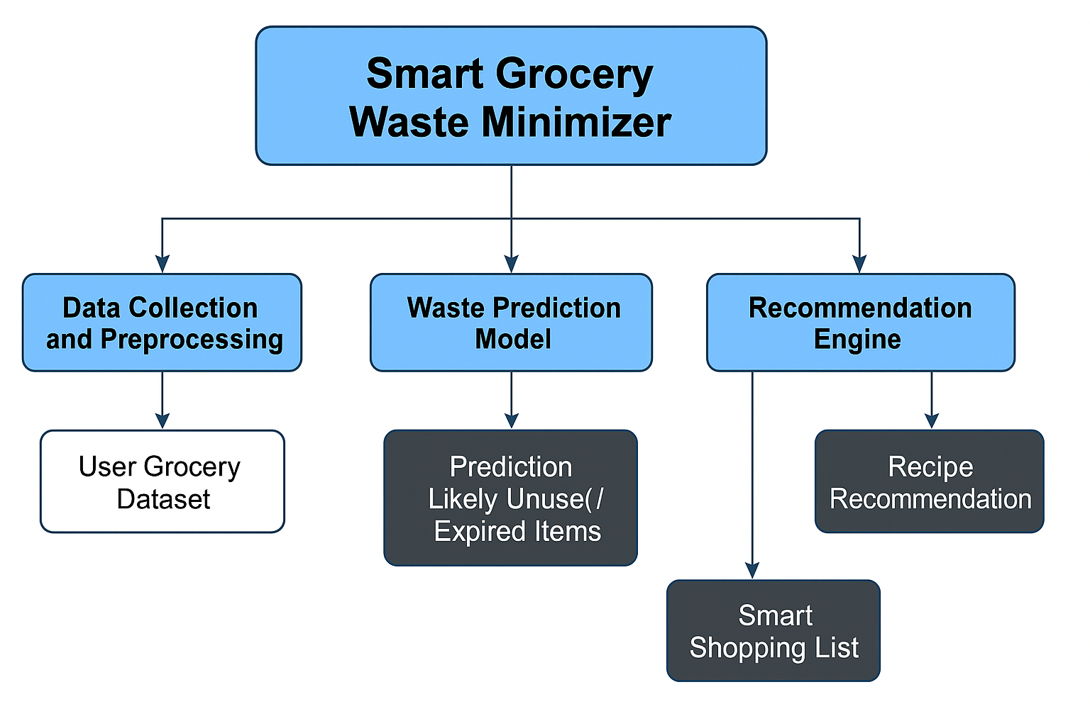

5.Implementation:
Sample code :

6.Conclusion

7.References:
Ref. No. | Paper / Source | Tech Stack Used | Methodology / Approach | Outcome / Findings
[1] | R. F. Buzby, J. Hyman, “The Estimated Amount, Value, and Calories of Postharvest Food Losses…”, USDA, 2012. | Statistical Data Analysis (Python, Excel, R) | Empirical estimation of food loss using economic and consumption data | Provided foundational dataset for waste quantification in the U.S.
[2] | M. Verma et al., “IoT-Based Smart Kitchen System for Food Waste Reduction”, IEEE Access, 2021. | IoT Sensors (Raspberry Pi, Arduino), Python, MQTT, Flask | Smart fridge using temperature sensors & item tracking to predict spoilage | Real-time monitoring achieved 28% reduction in kitchen waste
[3] | S. Kaur et al., “A Machine Learning Approach to Food Waste Management”, IJETT, 2020. | Python, scikit-learn, pandas, Flask | Logistic Regression & Random Forest for waste prediction | ML models predicted waste probability with 87% accuracy
[4] | N. H. Ramli et al., “Smart Food Waste Management System Using IoT and ML”, IEEE ICSPC, 2022. | Python, TensorFlow, NodeMCU, Firebase | IoT-based food detection system with CNN model | ML-driven classification reduced food waste mismanagement by 40%
[5] | UNEP, “Food Waste Index Report 2024”, UN Environment Programme | Data Collection, Statistical Indexing | Global statistical methodology for household waste estimation | Established global benchmarks for waste tracking
[6] | A. S. Pinto et al., “Predictive Analytics for Reducing Household Food Waste”, Journal of Cleaner Production, 2023 | Python, scikit-learn, SQL, Tableau | Time-series forecasting and behavior analysis | Predicted household food waste based on weekly consumption
[7] | E. Shafiee-Jood and C. Cai, “Reducing Food Loss and Waste…”, Environmental Science & Tech, 2016 | R, Linear Programming, Optimization | Food supply chain optimization model | Showed potential of AI-based logistics for waste reduction
[8] | A. F. Alvarenga et al., “Machine Learning Approaches for Food Waste Forecasting”, Sustainability, 2023 | Python, XGBoost, LightGBM, pandas | Feature-based classification of wasted vs used items | Achieved F1-score of 0.90 for waste prediction
[9] | P. R. Kumar, “Smart Inventory Management Using AI for Household Applications”, IEEE Trans. on Consumer Electronics, 2021 | Python, TensorFlow, SQLite, Android Studio | Image-based tracking of food items and expiry detection | Integrated ML + mobile app reduced waste by 32%

